Document A

1741 Captain’s Orders to Richard Derby
(Transcription is modified for length and clarity.)
Richard Derby of Salem was captain of Volant, a ship owned by Salem merchant Benjamin Gerrish. This is an excerpt of a letter (or captain’s orders) Gerrish wrote to Derby in 1741. Gerrish gave Derby instructions for where and how to trade Volant's cargo in the West Indies, and included a request that Derby purchase an enslaved child.
Captain Richard Derby,
When our schooner Volant, which you are captain of, is fully loaded, our orders are that you embrace the first fair wind and weather and sail for the island of Barbados.
When you arrive, visit merchant Mr. Gedney Clark, to see if he has procured a permit for you to go to any one of the French islands to trade. But if he has not and cannot do so, then seek one from anyone else.
If you cannot get a permit or if you think it not a good idea to trade at Barbados, then proceed directly to Martinique or Guadalupe islands and use the safest methods you can to trade; and don’t let your people trade for any trifle which may get you into trouble.
But if you’re so unlucky and cannot trade with the French, then proceed for the English islands, and use your best efforts both in the sale of your cargo, and security of your vessel against the hurricanes.
Wherever you trade sell the cargo that you judge will be most profitable.
Note written on the side:
Captain Derby,
If you trade at Barbados, buy me a Black boy about seventeen years old, and if you do, tell Mr. G. Clarke so he may not send one also.
-Benjamin Gerrish, Jr.

Image Source
Derby Family Papers, MSS 37, Box 6, Folder 6
Courtesy of The Phillips Library, Peabody Essex Museum, Salem, Mass

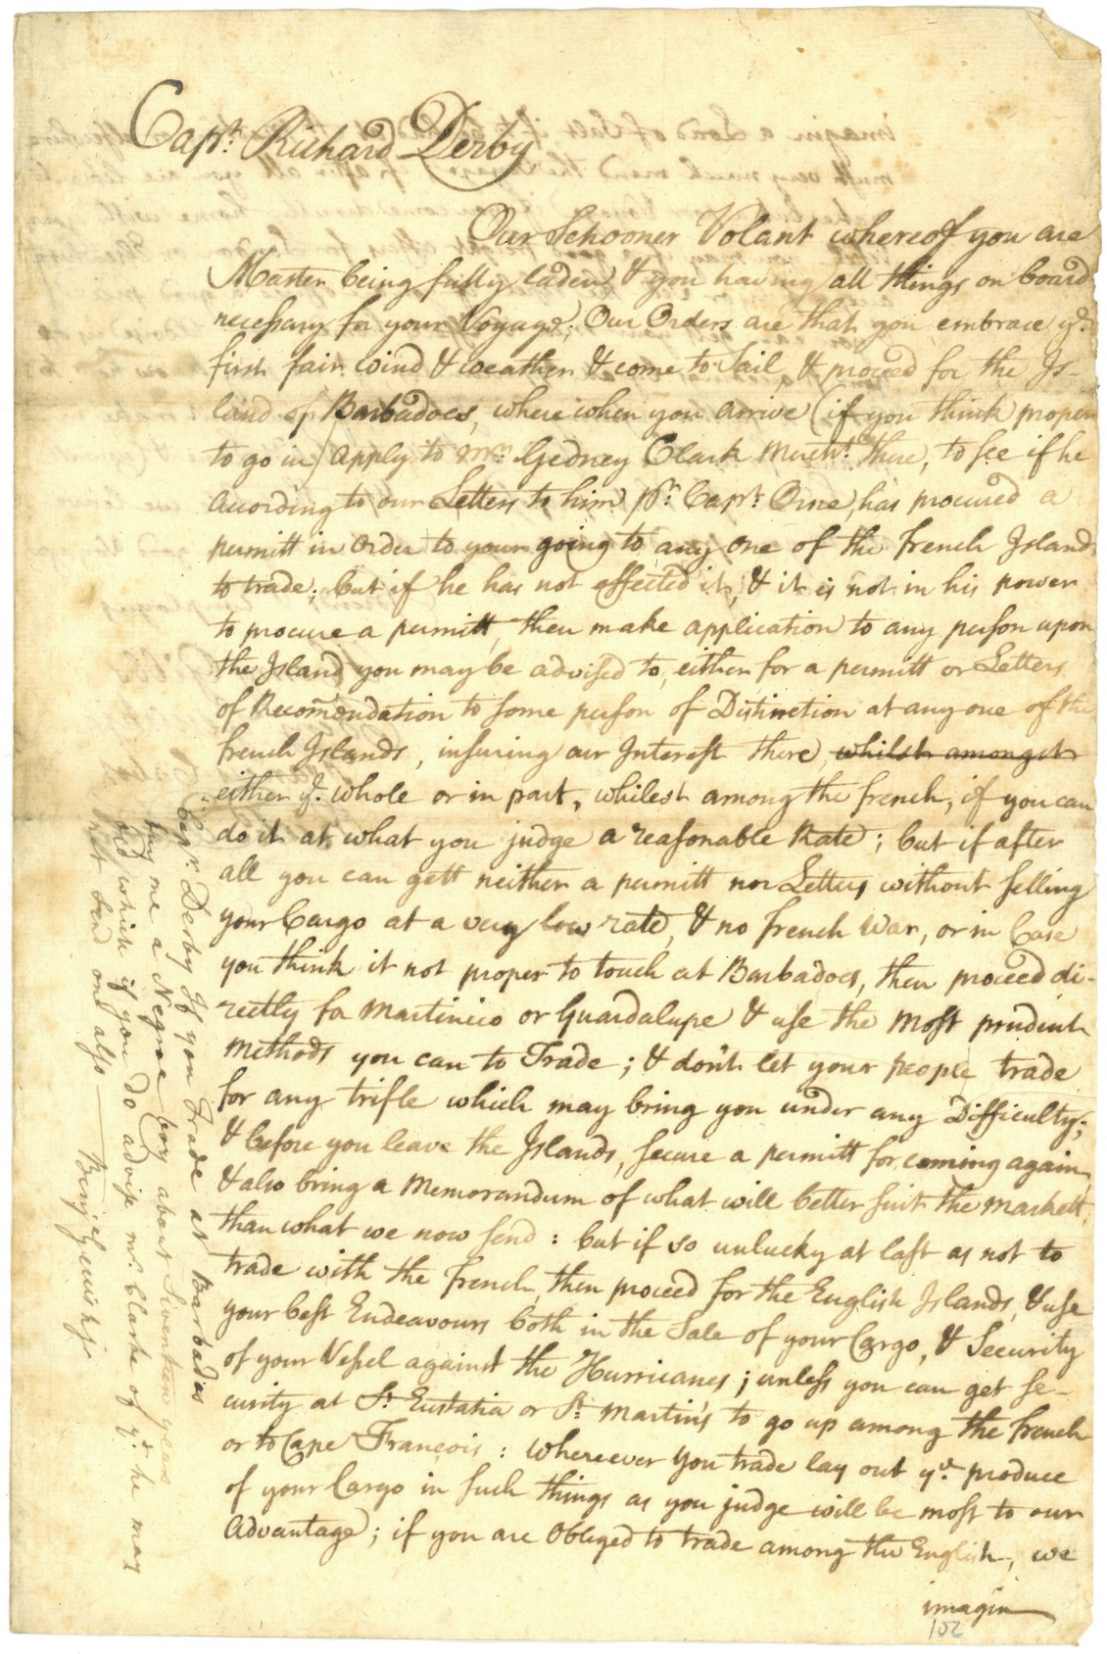

Document B

Account of Sales of Schooner Pembroke

(Transcription is modified for length and clarity.)
Pembroke was a trading vessel (ship) owned by Richard Derby of Salem. In 1764 Pembroke traveled to the island of Dominica in the West Indies. This is a record of items from New England (listed on the left) sold or exchanged in Dominica. Pembroke returned to Salem with items from Dominica (listed on the right).

Account of sales of the Schooner Pembroke  Cargo at Dominica  February through August 1764 |  |  | Account of the Schooner Pembroke  Cargo from Dominica  April 27, 1764
 | Pounds…. shillings… pence |  |  | Pounds…. shillings… pence
348 barrels of fish | 313.. 13.. 0 |  | 4 hogsheads (barrels) of sugar | 79.. 16.. 0
9 feet of boards (lumber) | 36.. 00.. 0 |  | 90 hogsheads of molasses  or 96 hogsheads and 11 tierces (barrels) | 472.. 16.. 0
11 barrels of alewives (fish) | 13.. 14.. 0 |  | 1 hogshead of coffee | 24.. 7.. 0
1 barrel of cod fish | 1.. 4.. 0 |  | Commission on sales at 5% | 37.. 4.. 0
11 horses | 220.. 0.. 0 |  | Commission on returns at 2.5% | 17.. 13.. 0
7 frames (lumber) | 60.. 0.. 0 |  | Bill of disbursements | 114.. 2.. 10
1,000 hoops | 3.. 0.. 0 |  | (Total) | 1745.. 18.. 10
24 tierces (barrels) of rice | 96.. 00.. 0
3 empty tierces | 1.. 16.. 0
2 small spars | .. 12.. 0
(Total)  Errors Excepted  Henry Elkins | 745.. 19.. 0 |  | Errors Excepted  Henry Elkins

Document B

Vocabulary
- Schooner: a type of sailboat
- Pounds, shilling, pence: English currency (money)
- Barrel (in the 18th century): a large round container used to package trade goods. These wooden containers came in different sizes with different names, including pipe barrel, hogshead, and tierce.
- Hoop: a ring or circular piece of wood used to make a barrel
- Spar: a wooden pole used to support a boat’s sail

Image Source
Derby Family Papers, MSS 37, Box 6, Folder 6
Courtesy of The Phillips Library, Peabody Essex Museum, Salem, Mass.

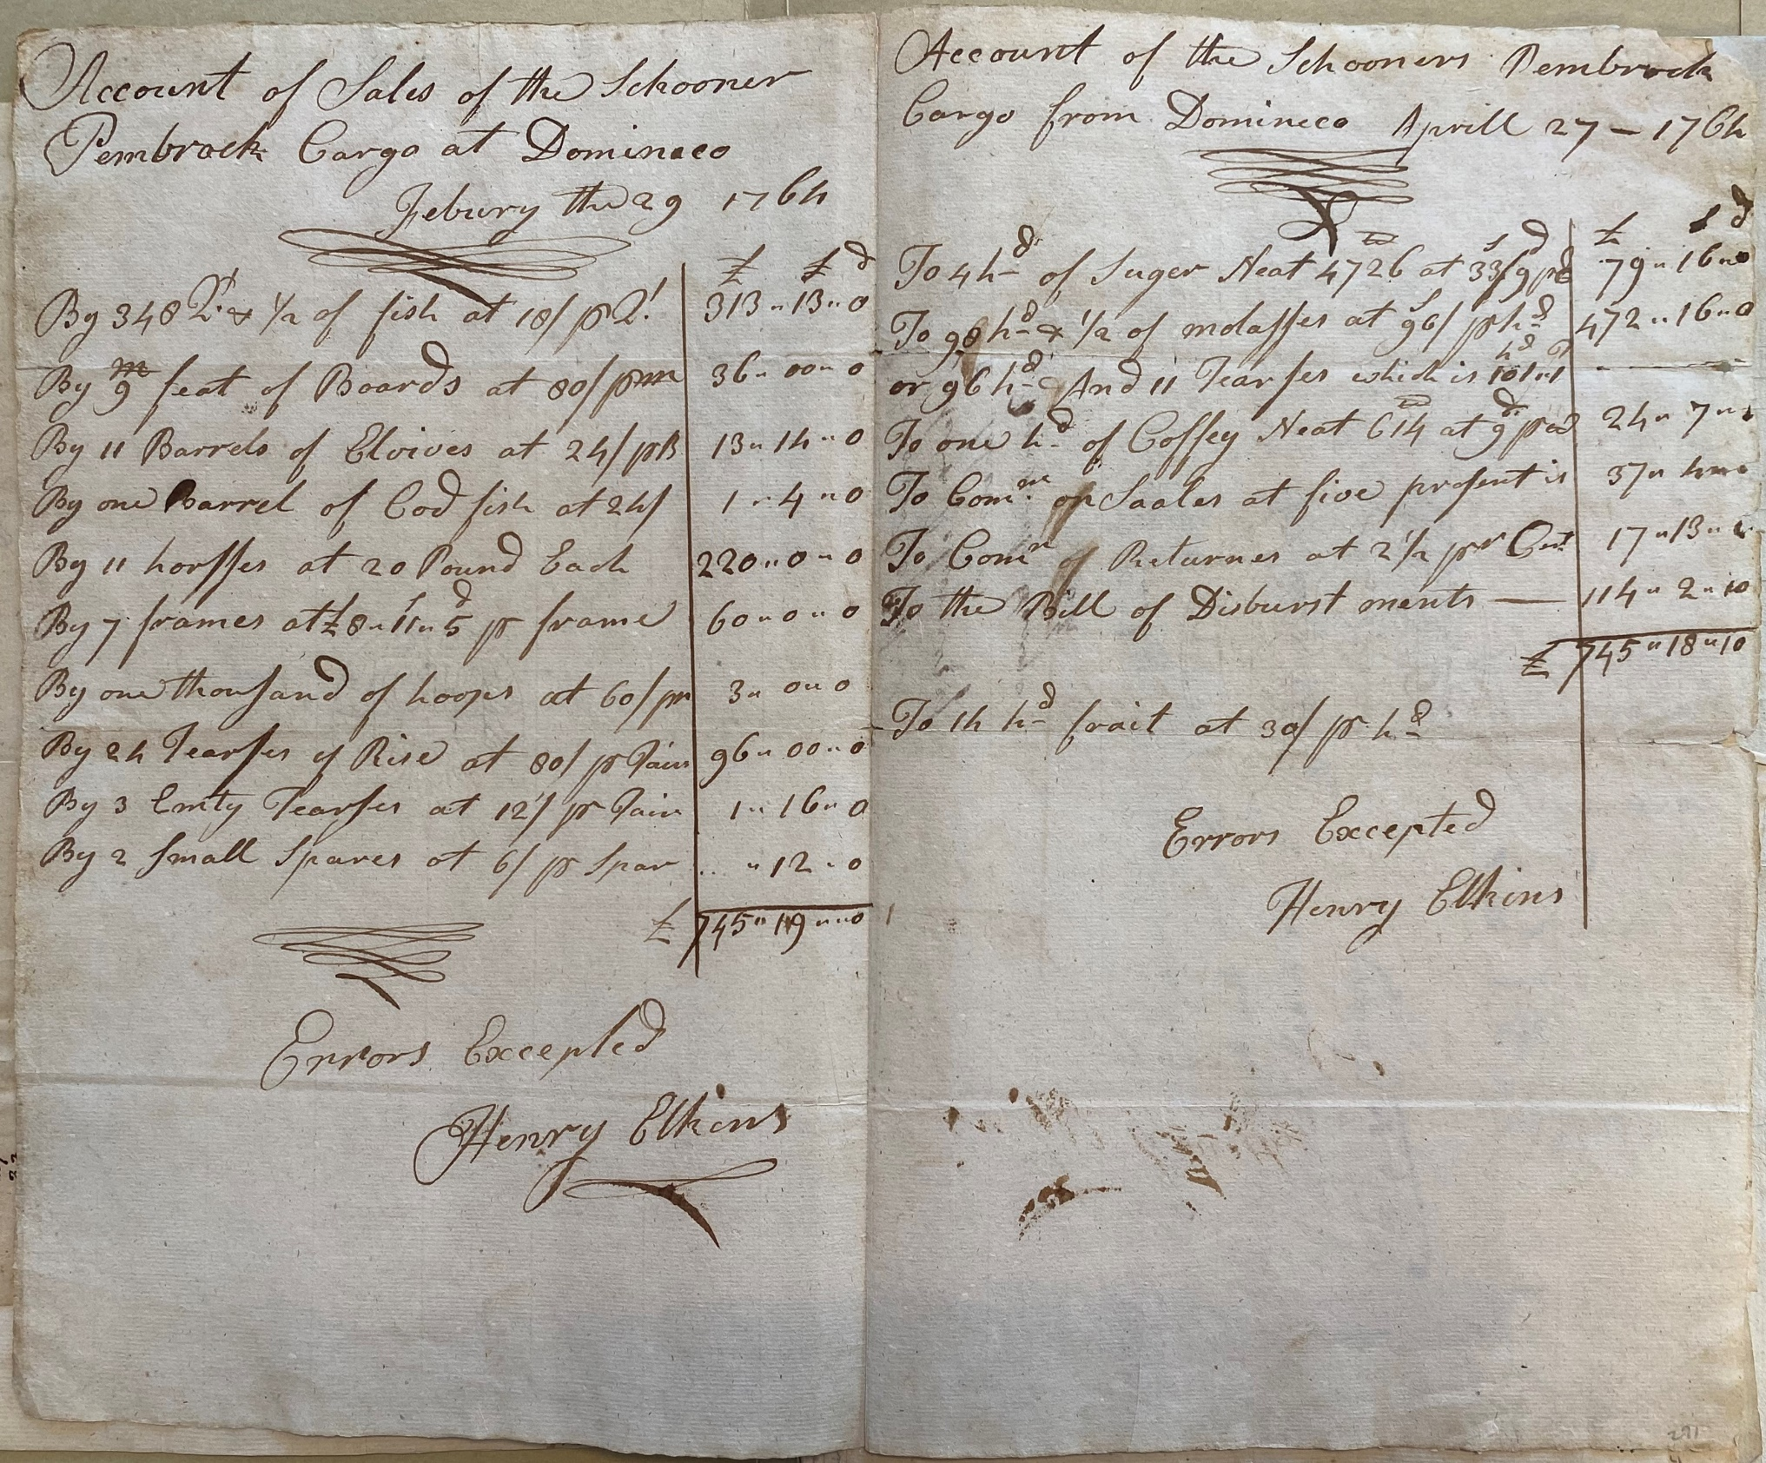

Graphic Organizer & Guiding Questions

Opening Question – Answer before reading the documents.
#1
How do you think Salem colonists viewed slavery?
Explain your opinion.

Graphic Organizer
 | Document A  Captain’s Orders to Richard Derby | Document B  Account of Sales of Schooner Pembroke
#2
What kind of document is this? (Why was it written or what was its purpose?)
#3
When was the document written?
Where?
What other places are mentioned?

 | Document A  Captain’s Orders to Richard Derby | Document B  Account of Sales of Schooner Pembroke
#4
What was happening in this time/place that helps explain this document?

#5
What evidence is there of Salem’s connections to different parts of the world?

What were the connections / how were they made?
#6
What evidence is there of the system of slavery?

Who is involved and how?

(Answer only for people specifically mentioned in the document.)

 | Document A  Captain’s Orders to Richard Derby | Document B  Account of Sales of Schooner Pembroke
#7
How does this document give us insight into the ways people profited from slavery?

Give two specific examples (citing evidence from the document) of New England professions that either supported or relied on slavery in the West Indies.

Closing Question – Answer after completing the Graphic Organizer.
#8
How do you think Salem colonists viewed slavery?

Explain your answer using evidence from the document, Background information, and answers from your Graphic Organizer.

